Citizenship, Economics and Society (Secondary 1-3)
“3-minute Concept” Animated Video Clips Series:
The Convention on the Elimination of all Forms of Discrimination Against Women”
Teaching Guidelines

1. Title of the Animated Video Clip: “The Convention on the Elimination of all Forms of Discrimination Against Women”
2. Duration of the Animated Video Clip: Around 3 minutes
3. Related CES Module: Module 1.4 Rights and Duties
4. Introduction of the animated video clip: The animated video clip was developed by the Personal, Social and Humanities Education Section, Curriculum Development Institute, Education Bureau. It uses daily examples and simple language to succinctly explain the concept of elimination of discrimination which included in “The Convention on the Elimination of all Forms of Discrimination Against Women”.
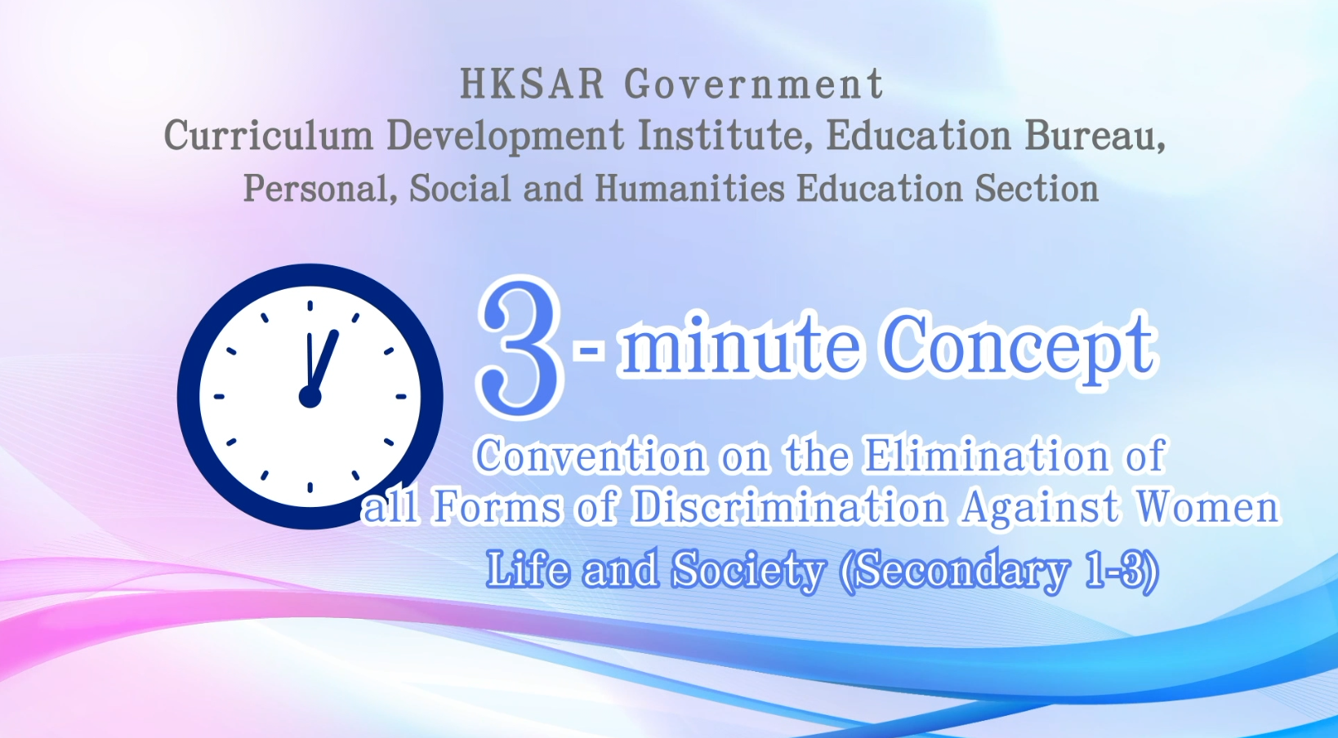
Citizenship, Economics and Society (Secondary 1-3)
Video link: https://emm.edcity.hk/media/Citizenship%2C+Economics+and+Society+%223-minute+Concept%22+Animated+Video+Clips+SeriesA+%2817%29+The+Convention+on+the+Elimination+of+all+Forms+of+Discrimination+Against+Women+%28English+subtitles+available%29/1_qtme9uj9
5. Teaching tips: Teachers must explain the following main points to students after playing the “The Convention on the Elimination of all Forms of Discrimination Against Women” animated video clip:
1) The Basic Law prescribes how international agreements apply to the HKSAR | Teachers should point out to students that according to Article 153(1) of the Basic Law, “The application to the Hong Kong Special Administrative Region of international agreements to which the People's Republic of China is or becomes a party shall be decided by the Central People's Government, in accordance with the circumstances and needs of the Region, and after seeking the views of the government of the Region.” Teachers may further point out to students that before resuming the exercise of sovereignty over Hong Kong, the Chinese government informed the Secretary-General of the United Nations in writing that the Convention on the Elimination of All Forms of Discrimination against Women (CEDAW) would continue to apply to the HKSAR with effect from July 1, 1997. This reflects that the ICERD applies to Hong Kong under the authorisation of the Chinese Government.
2) The Sex Discrimination Ordinance and related legal liabilities | Teachers should point out to students that Hong Kong is an international city with respect for the rule of law, equality and freedom and that any behaviours involving discrimination against others is likely to break the law and be subject to legal liability. Teachers should further point out to students that among the current anti-discrimination laws in Hong Kong, the Sex Discrimination Ordinance clearly states that discriminatory and sexual harassment acts against a person based on sex, marital status, pregnancy and breastfeeding are unlawful. The Ordinance covers different areas, such as employment and education, and protects men and women.  Teachers should help students understand the important messages contained in the relevant international agreements (e.g., equal rights and opportunities, the elimination of prejudice and discrimination, special care and assistance, etc.) so as to develop students’ positive values such as equality and care for others. Students are not required to memorise the content of the provisions. Therefore, teachers should not directly teach the provisions of international conventions word for word in class, nor should they require students to rote memorise them.  Teachers can refer to the following resources:  Sex Discrimination Ordinance  https://www.elegislation.gov.hk/hk/cap480!en?INDEX_CS=N  Equal Opportunities Commission - Sex Discrimination  https://www.eoc.org.hk/en/discrimination-laws/sex-discrimination-laws
3) The functions of the Equal Opportunities Commission in eliminating sex discrimination | The Equal Opportunities Commission (EOC) is a statutory body responsible for implementing and enforcing four anti-discrimination ordinances in Hong Kong: the Sex Discrimination Ordinance, the Disability Discrimination Ordinance, the Family Status Discrimination Ordinance, and the Race Discrimination Ordinance. Through handling complaints related to sex discrimination, conciliating disputes, representing victims in court, conducting empirical research and policy advocacy related to sex discrimination, and arranging corporate training and public education, the EOC strives to dismantle sex prejudice and discrimination in the community and promote the values of gender equality. For details on the functions of the EOC, teachers can refer to the following resource:  Equal Opportunities Commission - About the EOC  https://www.eoc.org.hk/en/about-the-eoc/introduction-to-eoc
4) Elimination of sex discrimination depends on the concerted efforts of society | Teachers should point out to students that apart from the government, private sectors and the community have different roles and responsibilities in eliminating sex discrimination. Teachers are suggested to explain to students how individuals can help build a harmonious and equal community. The private sector also has a social responsibility to eliminate sex discrimination. For example, during recruitment, employers should ensure equal employment opportunities and employ people based on talents and knowledge instead of turning down candidates just because of their gender. Furthermore, the community should pay more attention to the issue of gender equality. We should discard old-fashioned concepts such as “men are superior while women are inferior” and “men should take care of external affairs while women should handle domestic ones” to build an equal society with respect, tolerance and care.

6. Consolidation questions: (See next page)

“3-minute Concept” Animated Video Clips Series:

“The Convention on the Elimination of all Forms of Discrimination

Against Women”

Worksheet

A. Multiple Choice Questions
Circle the correct answers.
- In Hong Kong, sex equality is protected by which legislation(s)?
i. The Sex Discrimination Ordinance
ii. The Personal Data (Privacy) Ordinance
iii. The Family Status Discrimination Ordinance
iv. The Disability Discrimination Ordinance

A. i
B. i, iii
C. ii, iv
D. i, ii, iii, iv
Ans: B

- According to the Sex Discrimination Ordinance, which of the following is unlawful?
  - It is unlawful to discriminate, harass or vilify a person on the ground of his/her race in prescribed areas of activities.
  - It is unlawful to discriminate against a person on the ground of sex, marital status, pregnancy or breastfeeding in prescribed areas of activities.
  - It is unlawful to discriminate against a person on the ground of disability when committed in prescribed areas of activities.
  - It is unlawful to discriminate against a person on the ground of family status.
Ans: B

B. True or False
Study the following sentences about the Convention on the Elimination of all Forms of Discrimination Against Women. Put a “T” in the blank for correct description and an “F” for incorrect description.
 | The Convention on the Elimination of all Forms of Discrimination Against Women aims at safeguarding women to enjoy basic human rights and freedoms in the political, economic, social, cultural, civil or any other spheres of life without being treated differently, being excluded or being restricted because of their gender and to ensure that women can develop themselves to the fullest. | T
 | The Convention on the Elimination of all Forms of Discrimination Against Women continues to apply to the Hong Kong Special Administrative Region effective from 1 July 1997. | T
 | Office of the Privacy Commissioner for Personal Data is responsible for monitoring the implementation of the Sex Discrimination Ordinance and the Family Status Discrimination Ordinance. | F

C. Short Question
How can you contribute to sex equality in your daily lives?
- To avoid gender stereotypes, such as the views that “men should
take care of external affairs while women should handle domestic
ones” or “men are superior while women are inferior”, etc.
- To enhance sensitivity to sex-related conversation and behaviours.
- To concern about the sex equality issues.

 The End 

